

*BIG DATA VISUALIZATION*

(Video Game Sales Globally)

Software: - Tableau

By: -Abhishek Glasswala

Year: - 2023

Table of Contents

1. INTRODUCTION 3

1.1. ADVANTAGE OF DATA ANALYTIC IN SELECTED FIELD 4

1.2. IMPACT OF BIG DATA ON COMPANY AND SOCIETY 4

2. DATA BRIEFING 5

2.1. DATA CLEANSING AND PROCESSING 5

2.2. IDENTIFY KEY METRIC AND RELATIONSHIP 6

2.2.1. VIDEO GAME SALES BY GENRE AND REGION (2000-2015) 6

2.2.2. MOST POPULAR PLATFORM AND TOP SELLING GAMES. 7

2.2.3. GLOBAL SALES OF VIDEO GAME 7

2.2.4. REGIONAL CONTRIBUTION TO TOTAL VIDEO GAME SALES. 8

3. STRATEGIC INSIGHT 10

4. RECOMMENDATIONS 10

5. CONCLUSION 11

6. APPENDICES 12

7. REFERENCES 16

*FIGURE 1 VIDEO GAME SALES BY GENRE AND REGION* 6

FIGURE 2 MOST POPULAR PLATFORM AND TOP SALLING GAMES 7

FIGURE 3 GLOBAL SALES OF VIDEO GAME 8

FIGURE 4 REGIONAL CONTRIBUTION TO TOTAL VIDEO GAME SALES 9

# INTRODUCTION

Big data refers to extremely large and intricate collection of data, primarily obtained from novel data sources. These data set are so enormous that conventional data processing software lacks the capacity to handle them. However, these colossal amounts of data can be leveraged to solve business challenges that were previously beyond reach. This enables origination to utilize their data to discover novel prospects, resulting in more intelligent business decision operation, increased profit, and most staffing customer. Moreover, data analytic is fast, accurate and efficient. A few years ago, business collected information, analyzed it, and found information that could be use later. Nowadays, businesses can collect data and analyses it right away to make better decision. Being able to work faster gives businesses an advantage they did not have before. Data sets are majorly gathered from social media sources, which help institution gather information on customer needs and most often stored in computer database to analyze using software like tableau for visualization, can help people to understand and make sense of complex information more easily then presenting it in traditional format such as table and text however, the structure of data visualization is based on the principles of visual prediction and cognitive psychology, which aim to designee representation which are clear, concise and meaningful. It also involved choosing the appropriate type of visualization to represent data accurately. It easy to observe and comprehend trends, anomalies, and patterns in data by incorporating visuals elements such as chart, graph, and maps.[1][2]

The use of big data has led to remarkable achievements across many sectors, including healthcare, retail, finance, and manufacturing. From improving patient outcome to optimizing production processing, big data has the potential to drive significant improvements in efficiency, productivity, and profitability. In this project, we will explore the impact of big data in “Video Game Sales (globally)” and examine the key trends and statistic that highlight its transformative power. [11]

## ADVANTAGE OF DATA ANALYTIC IN SELECTED FIELD

The dataset concerning “Video game sales (globally)” that will be utilized in this report was obtained from Kaggle.com (Data visualization section). Website creating to data scientists engaged in resolving problems associated with data science, machine learning, and predictive analytics. Kaggle supplies a platform for individual world wield to collaborate on dataset, share code, or host their own datasets. The “Video game sales (globally)” dataset is freely available and accusable to anyone from use.

Data analysis has become an integral part of the gaming industry, and it can provide valuable insights that can help improve the user experience and inform business decisions. The role of a data analyst in the gaming industry is crucial to understanding gamer’s user data – behavior’s, play time, interactions as well as supporting gaming companies for actionable insights (Amad, y, 2018) [3].

Through data analysis, gaming companies can gain a better understanding of their users, their preferences, and their behaviors. This enables them to design games that are more engaging and immersive, leading to a better overall user experience. In addition, data analysis can help gaming companies to optimize their marketing strategies by identifying the most effective channels and messages to reach their target audience [4]

## IMPACT OF BIG DATA ON COMPANY AND SOCIETY

Bid data has an enormous impact on both company and society. "Business analytics is not about data; it is about solving business problems." (James Kobielus, 2012). The primary goal of a business analytics is merely to gather and examine data but to utilize the knowledge get from data analysis to solve business-related problems and meet organizational goals. The introduction of modern analytical methods and big data in the video game industry has had a positive impact on both the companies and society. The use of these methods has provided companies with a clear advantage in terms of understanding the gaming requirements of different age groups, popular games, and future gaming trends. This has allowed companies to tailor their products to the specific needs and wants of their customers, resulting in a more effective supply chain and boosted growth. The impact on society has also been significant. Customers are now able to compare related products based on price, efficiency, popularity, and ratings, making it easier for them to choose the product that best suits their needs. This has resulted in increased transparency and competition in the industry, ultimately benefiting the consumer. The integration of big data and modern analytical methods in the video game industry has resulted in increased efficiency, profitability, and growth for companies, while providing consumers with a more informed and satisfying gaming experience *(reinsel, D. 2018) [5]*

# DATA BRIEFING

As early mentioned, dataset on "Video Game Sales", available on Kaggle.com,[10] is a comprehensive collection of data that provides valuable insights into the global sales in million unite of games across different platforms and genres. This dataset is a great resource for learning and gaining insights into the gaming industry, as it contains information on the sales of the top 100 video games worldwide, along with their platforms, genres, and publishers.

The dataset comprises 11 columns, including rank, name, platform, year of release, genre, publisher, and sales data from different regions across the world. This enables analysts to draw comparisons between various specific aspects or discover general trends about certain parts of the industry over a prolonged period. By analyzing this data, it is possible to identify the most popular gaming platforms driving global sales and observe the most successful genres associated with those platforms. Furthermore, this dataset allows one to determine which publishers have achieved success in publications of multiple series or even single titles.[6]

This dataset is a valuable resource for understanding the relationship between gaming platforms, genres, and global sales. It provides insights into the gaming industry, allowing for identification of trends that contribute to the success of game developers. By leveraging this information, developers can create more successful titles and make informed decisions about their target audience and platform preferences.[7]

## DATA CLEANSING AND PROCESSING

Data cleaning involves identifying and correcting such inconsistencies and errors to ensure the accuracy and reliability of the data. It is an essential step in preparing data for analysis and ensuring that the results obtained are meaningful and trustworthy. There is an often repeated saying in data analysis: “Garbage in, garbage out,” which means that, if started with bad data (garbage), you’ll only get “garbage” results [9]. In order to professionally clean and report on the data, a comprehensive dataset was compiled that included key metrics such as Rank, Name, Platform, Years, Genre, Publisher, Country Code, North America Sales, European Union Sales, Japan Sales, Other Sales, Global Sales, Sales Ratio, Unclear Data, Review Scores, and other informative data. Extraneous information was removed, and the Excel file was modified and

updated with additional relevant details. The resulting dataset is now prepared for further analysis and reporting on video game sales trends and performance.

## IDENTIFY KEY METRIC AND RELATIONSHIP

The diagrams show the key metrics for video game sales categorized by genre and region. These metrics include the number of units sold for each video game in North America, Europe, Japan, and other countries. Correlations between these metrics have been identified and are displayed in the diagrams, which supply explanations for the observed relationships.

### VIDEO GAME SALES BY GENRE AND REGION (2000-2015)

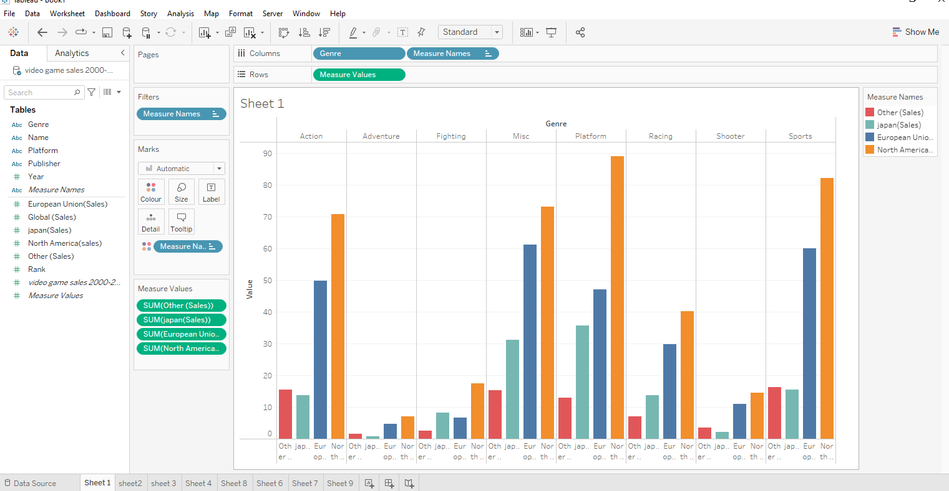

*FIGURE 1 VIDEO GAME SALES BY GENRE AND REGION*

The bar graph shows the total number of video game sales, measured in millions of units, for different genres between the years 2000 and 2015. The graph provides information on video game sales in Japan, the European Union, North America, and other regions for genres including Action, Adventure, Fighting, Misc., Platform, Racing, Shooter, and Sports. It appears that North America had the highest sales of video games across all genres during this period, with Platform games selling almost 90 million units in the region. Conversely, Adventure, Fighting, and Shooter games had the lowest sales globally.

### MOST POPULAR PLATFORM AND TOP SELLING GAMES.

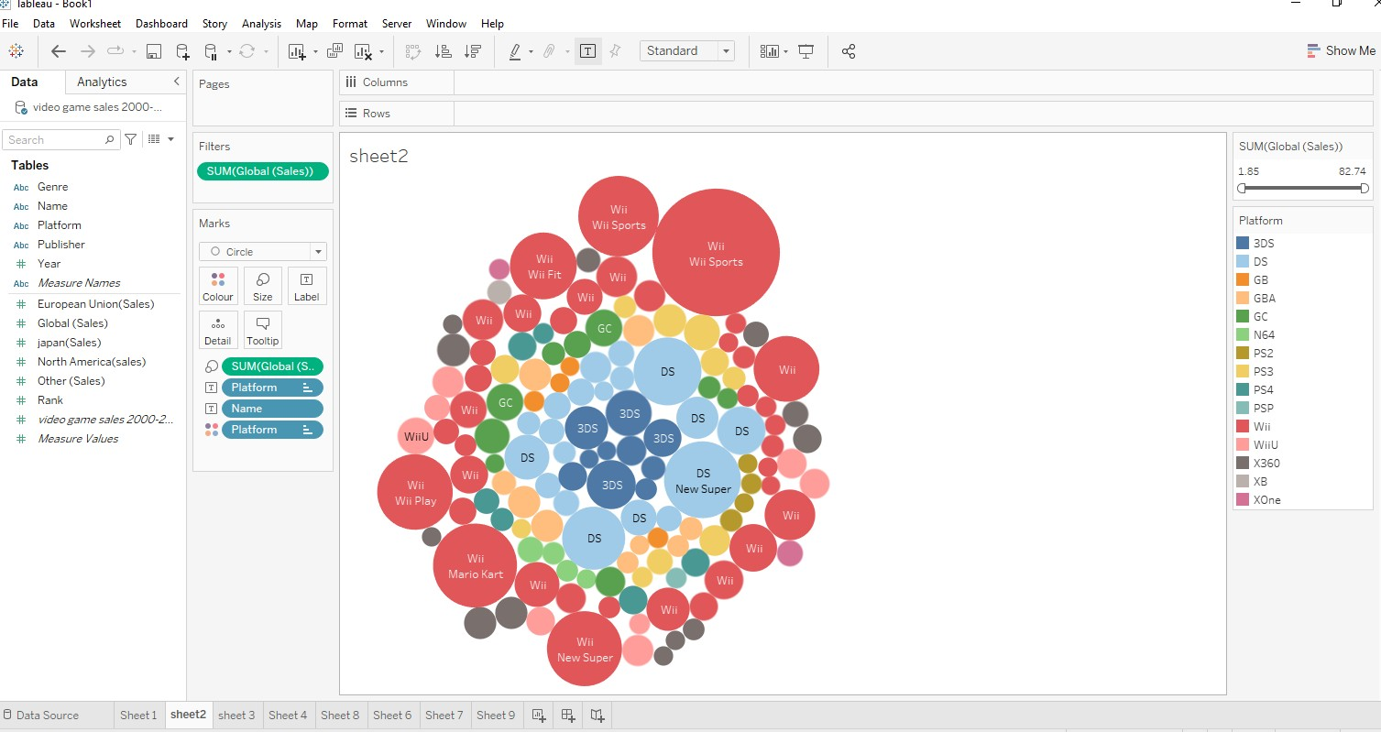

**FIGURE 2 MOST POPULAR PLATFORM AND TOP SALLING GAMES**

The bubble plot diagram displays information about the most popular video game platforms. The diagram shows 15 different platforms available for players to use, and highlights the four most popular platforms: Wii, DS, GC, and 3DS. These four platforms have the highest global sales, while the popularity of XB and XOne is extremely low. The diagram also displays the names of the most sold games for each platform, with Wii Sports being the top-selling game about 87.4 million units sold on Wii and the second most sold game being Wii Sports Action which is 33 million sales globally. On the other hand, the lowest number of games sold belongs to the x360 platform, which is 3.46 million games sold, with Assassin's Creed being the least sold game.

### GLOBAL SALES OF VIDEO GAME

The line graph depicts the total sales of video games from different years. It reveals that between 2000 and 2004, the sales of video games were below 40 million units. However, after

that, there was a remarkable surge in the number of games sold, reaching 165.8 million units in 2006, which was almost four times the sales between 2000 and 2004. This surge in sales indicates a high demand for video games among the Total population.

Unfortunately, the trend was short-lived, as sales dropped to 62.5 million units in 2008. However, in 2009, there was a slight upward trend, with 122.8 million units sold.

Unfortunately, the sales of video games dropped significantly again after that, and by 2015, only 15.5 million units were sold in the year.

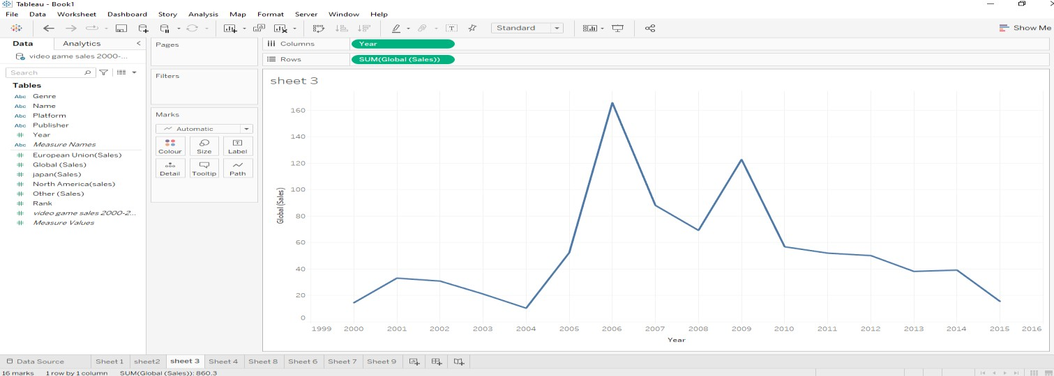

**FIGURE 3 GLOBAL SALES OF VIDEO GAME**

### REGIONAL CONTRIBUTION TO TOTAL VIDEO GAME SALES.

The bar graphs illustrate the contribution of different regions to the total video game sales between 2000 and 2015. The global sales are displayed on the right x-axis (right rows), while the years are shown on the y-axis (columns), and the regional sales are compared.

The analysis of the graphs reveals that North America made the highest contribution to video ga.me sales, with 75.58 million units sold in 2006. Meanwhile, the European Union also made a significant contribution to global sales, with 54.21 million units sold in 2006. On the other hand, Japan contributed around 20.5 million units in 2006.

It is evident from both the bar and line graphs that the peak in global sales occurred between 2006 and 2009, after which the video game market experienced a significant decline worldwide. This suggests a reduction in the popularity of video games. Moreover, the line graph's color stands for the volume of video game sales in a particular year, with the measurement described in the top right-hand side of the graph.

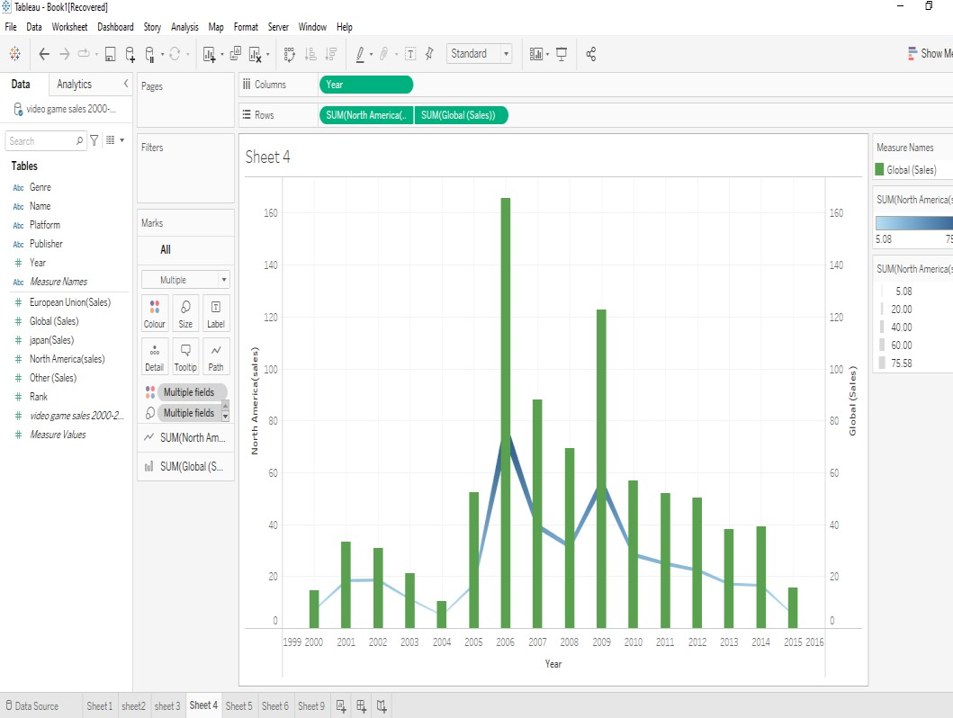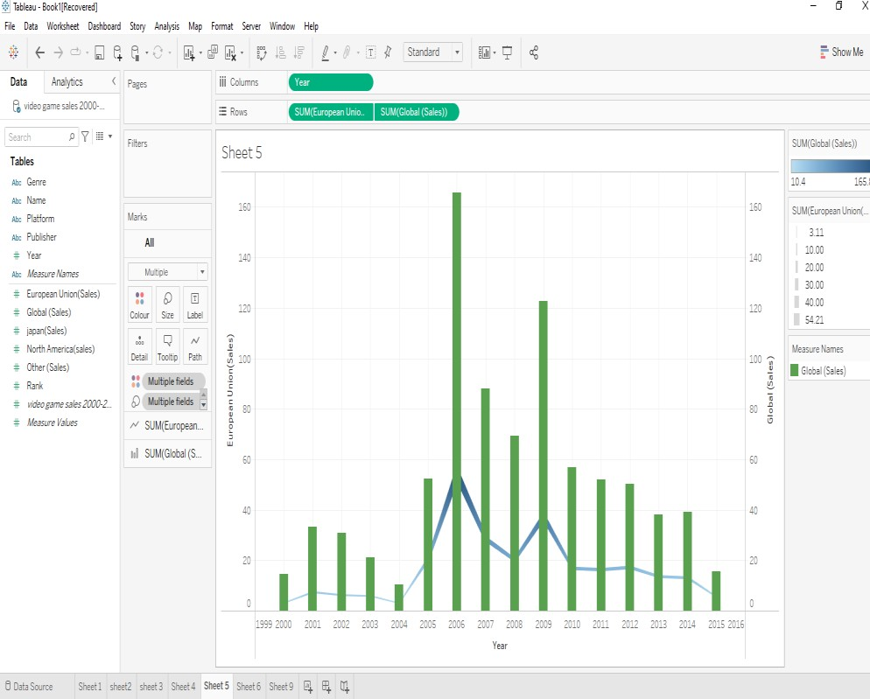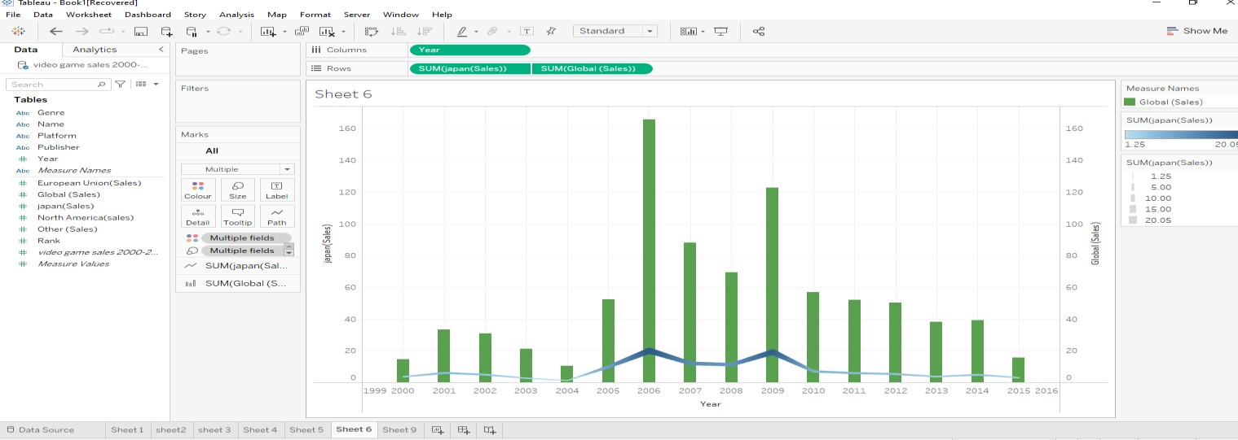9

**FIGURE 4 REGIONAL CONTRIBUTION TO TOTAL VIDEO GAME SALES**

# STRATEGIC INSIGHT

We have seen that video game companies are facing several challenges that could impact its future success. One significant challenge is the oversaturation of the market, which can lead to decreased interest and sales for companies. This issue can be addressed by focusing on a specific niche or demographic, investing in research and development to create innovative and exciting games, and improving marketing strategies to increase visibility and attract more customers.

Another significant challenge is the inflated cost of video games, which can make them unaffordable for a massive portion of the population. This problem can be addressed by offering more affordable subscription services, as well as mobile gaming options that are more accessible and affordable. Additionally, companies can invest in developing games with more diverse price points to appeal to a wider range of customers.

Furthermore, delays in game art design and shortages of chips needed to power gaming devices can also be problematic for the industry. This issue can be addressed by investing in better testing and quality assurance processes, as well as hiring more experienced developers to ensure timely and high-quality game releases. Companies can also explore modern technologies, such as cloud gaming, to offer innovative solutions that do not rely on powerful hardware.

Overall, the video game industry must address these challenges to remain competitive and successful. Companies must prioritize innovation, quality, and accessibility to attract and retain customers. As technology and consumer preferences continue to evolve, the industry must also adapt and stay ahead of the curve. By investing in research and development, improving marketing strategies, and addressing supply chain issues, the video game industry can continue to thrive in the years to come.

# RECOMMENDATIONS

To increase video game sales, consider offering discounts during off-seasons and unique events, adjusting prices to reflect customer value, and offering bundles and DLC packages. Implementing a free-to-play model and improving game quality can also attract customers. Utilize various marketing channels to reach wider demographics and offer in-game rewards to increase engagement and encourage word of mouth. Building a community around the game through forums, social media, and events can also drive sales.

# CONCLUSION

Based on the data and analysis, it can be concluded that there is significant variation in video game sales across different regions and genres. While North America tends to have higher sales, Japan has lower sales despite being a major player in the gaming industry. Additionally, fluctuations in sales over time suggest the importance of continually adapting to market trends and consumer preferences. However, it is important to note that these are general trends and there may be exceptions or unique factors that affect sales in specific cases.

APPENDIX 1

# APPENDICES

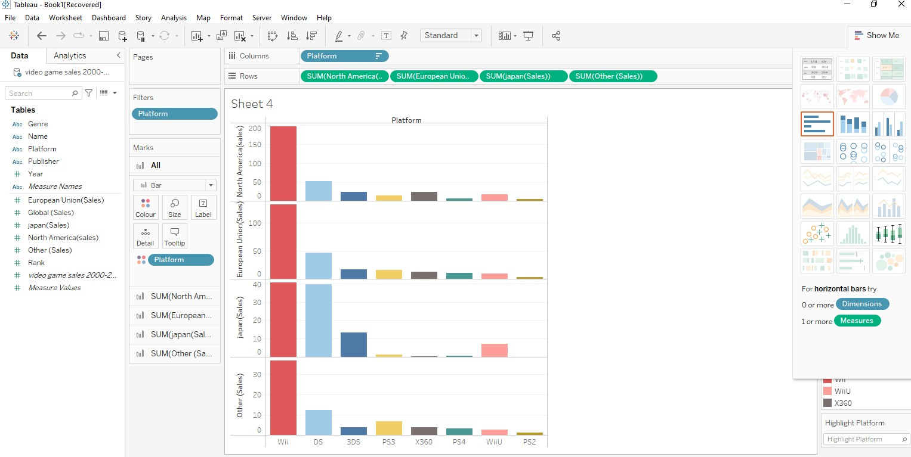

APPENDIX 2

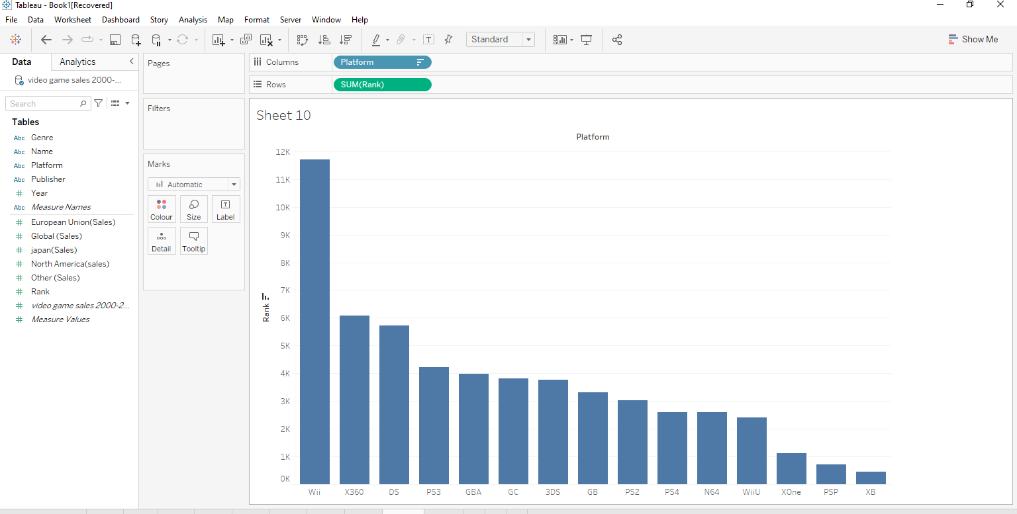

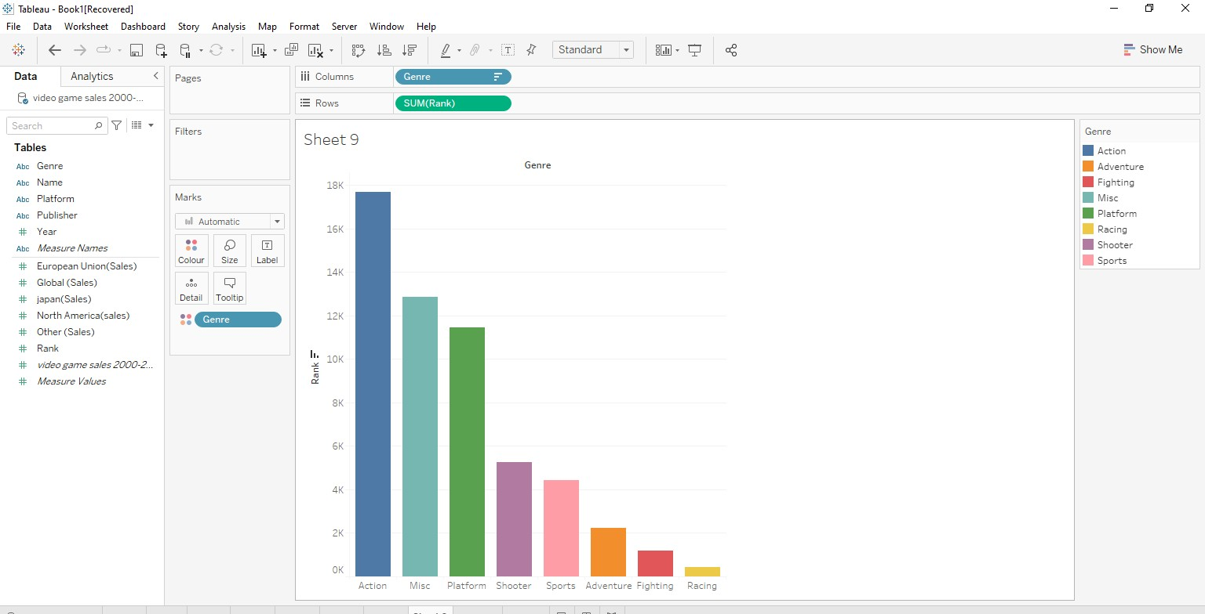

APPENDIX 3

Appendix4

APPENDIX 4

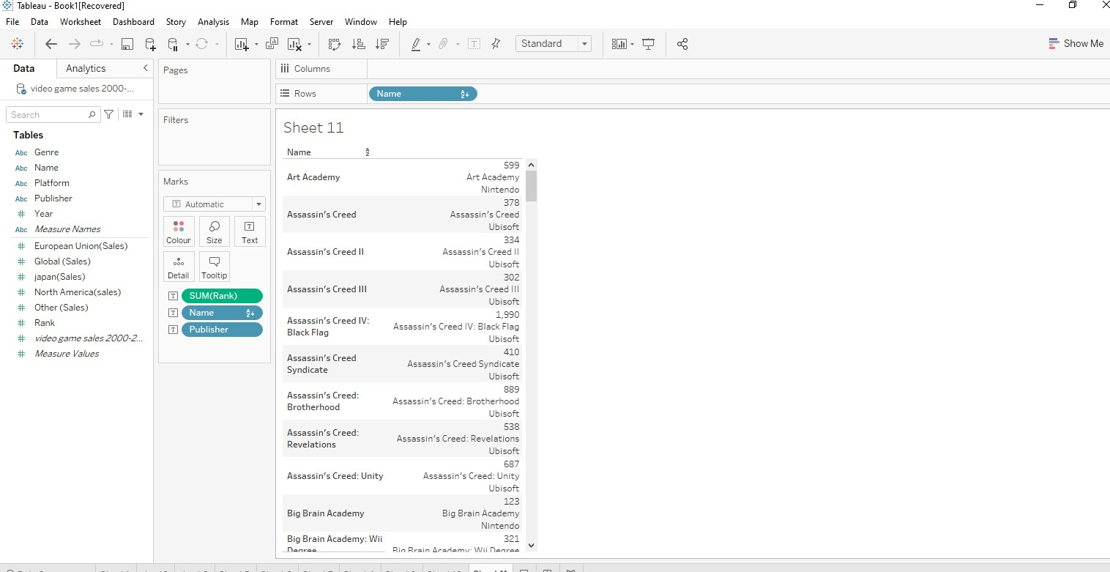

16

# REFERENCES

1. schroer, A. (2022). *BIG DATA*. builtin.com. <https://builtin.com/big-data>
2. Segal, T. (2022). *What Is Big Data? Definition, How It Works, and Uses*. [www.investopedia.com.](http://www.investopedia.com/) [https://www.investopedia.com/terms/b](https://www.investopedia.com/terms/b/big-data.asp)/big-data.asp
3. Amad, y. (2018). *5 Big Benefits of Data and Analytics for Positive Business Outcomes*. [www.teradata.com/Blogs.](http://www.teradata.com/Blogs) [https://www.teradata.com/Blogs/5-Big-Benefits-of-Data-and-](https://www.teradata.com/Blogs/5-Big-Benefits-of-Data-and-Analytics-for-Positive-Business-Outcomes)Analytics-for- Positive-Business-Outcomes
4. vivekanandarajh, A. (2018). *How data analytics software is changing the video game industry*. seleritysas.com. [https://seleritysas.com/blog/2018/12/14/data-analytics-](https://seleritysas.com/blog/2018/12/14/data-analytics-software-video-game-industry/)software-video-game- industry/
5. *reinsel, D. (2018). the impact of big data on business, workforce and society***.***.* [*www.tpptechnology.com.*](http://www.tpptechnology.com/)

[https://www.tpptechnology.com/blog/the-impact-of-big-data-](https://www.tpptechnology.com/blog/the-impact-of-big-data-on-businesses-workforce-and-society/)on-businesses-workforce-and-society/

1. (2021). *Big Data: Revolution To Transform Business Models*. indatalabs.com. [https://indatalabs.com/blog/impact-of-big-data-on](https://indatalabs.com/blog/impact-of-big-data-on-business)-business
2. branchereau, l. (2020). *The Impact of Big Data on Our World and Society*. mastertcloc.unistra.fr. [https://mastertcloc.unistra.fr/2020/03/23/impact-of-big-data-on-](https://mastertcloc.unistra.fr/2020/03/23/impact-of-big-data-on-our-world-and-society/)our-world-and-society/
3. (2023). *Video Gaming Industry in 2023: Gaming Devices & Video Game Content Viewership Trends*. [www.insiderintelligence.com.](http://www.insiderintelligence.com/) [https://www.insiderintelligence.com/insights/us-gaming-industry-](https://www.insiderintelligence.com/insights/us-gaming-industry-ecosystem/) [ecosystem](https://www.insiderintelligence.com/insights/us-gaming-industry-ecosystem/)/
4. ozminkowski, r. (2021). *Garbage In, Garbage Out*. towardsdatascience.com. <https://towardsdatascience.com/garbage-in-garbage-out-721b5b299bc1>
5. *Usmani, Z,. (2018). What is Kaggle, Why I Participate, What is* the Impact?. Kaggle. <https://www.kaggle.com/getting-started/44916>
6. ["Sales Data – Top Selling Title Sales Units – Nintendo 3DS Software".](https://www.nintendo.co.jp/ir/en/finance/software/3ds.html) [*Nintendo*.](https://en.wikipedia.org/wiki/Nintendo) September 30, 2020. Archived from the original on October 31, 2017. Retrieved November 5, 2020.